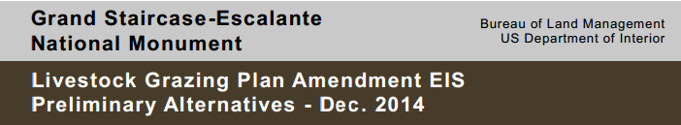
COMMENT CARD
HOW MAY WE CONTACT YOU?Click here to enter text.
Name:Click here to enter text.
Organization (if applicable):Click here to enter text.
Street Address (optional):Click here to enter text.
City/State/Zip (optional):Click here to enter text.
Email (optional):Click here to enter text.
(Please let us know if we can provide future mailings via email to conserve paper.)
Questions about Preliminary Alternatives
Thinking about your values and desires for the future of livestock grazing and the environment, are there one or more alternatives that you’ve heard about today that would best meet these? Which one(s)?
☐ Alternative A - No Action
☐Alternative B - No Grazing on GSENM and Glen Canyon NRA
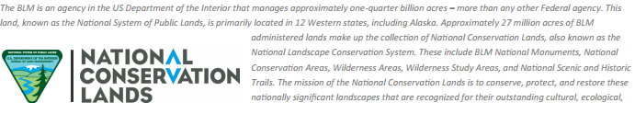
☐Alternative C - Prioritize Native Species
☐Alternative D - Increase Grazing and Improve Rangeland Health
☐Alternative E - Emphasize Sustained Use and Achieve Rangeland Health Standards
How would you improve, change, or add to the alternatives to be studied? Do you have any other suggestions? Attach additional pages as necessary:

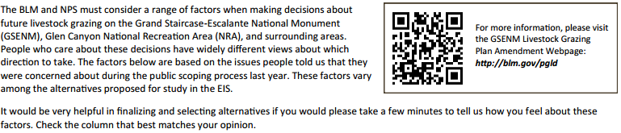
Factor or Objective | Not  Important | Somewhat  Important | Very  Important
Use of specific type(s) of grazing management practices, generally:
Season of use (time of year when livestock are present)
How long livestock are present (duration)
Where livestock are located (distribution)
How often areas are used by livestock (grazing systems such as rest-rotation, deferred rotation)
Use of range improvements (fences, pipelines, troughs, seedings)
Allocating AUMs based on amount and locations of available forage
Grazing contributions to local income and tourist economy (economics)
Maintaining grazing as a cornerstone of local culture
Protecting biological soil crust and managing erosion
Compatibility of recreational experiences with grazing activities
Conducting ecosystem monitoring and adaptive management
Understanding the relationship between grazing and healthy vegetation
Effects of grazing on biological / ecological resources
Protecting the quality and availability of natural water sources
Protecting riparian areas
Controlling noxious weeds and non-native invasive plants
Ability to manage grazing and forage under climate changes & drought conditions
Livestock damages to archaeological resources
Protecting the objects and values of the Grand Staircase Escalante National Monument (geology, cultural resources, vegetation, soils, unique ecosystems)
Maintaining wildlife access to water sources and habitat
Preserving the values and purposes of Glen Canyon National Recreation Area
Respecting tribal interests and Native American religious concerns
Reducing erosion and dust from destabilized soils
Protecting scenic views, especially the views near Bryce Canyon National Park
